Mechanical Vibrations Equation Sheet

**Free Vibrations without damping** **2**

**Viscous damping** **2**

Critical damping 2

Damping ratio 2

Underdamped system 2

Overdamped system 3

Critically damped system 3

Experimental identification 4

**Estimating stiffness of mechanical elements** **4**

Vertical beam 4

Shaft 4

Cantilever beam 5

Simply supported beam 5

Spring 5

**Springs** **5**

**Modeling using energy method** **5**

**Stability** **6**

Flutter instability 6

Divergent instability 6

**Coulomb friction** **6**

**Numerical simulations** **7**

**Harmonic excitation without damping** **7**

**Harmonic excitation with damping** **8**

Steady state response 9

Magnification factor 9

# Free Vibrations without damping

* + General form:
 $\ddot{x}+ω^{2}x=0$

 $ω=\sqrt{\frac{k}{m}} or \sqrt{\frac{g}{L}}$

  - General solution (3 forms):

$x(t)=C_{1}e^{iωt}+C_{2}e^{-iωt}$

$x(t)=A_{1}cos(ωt)+A_{2}sin(ωt)$

$x(t)=Asin(ωt+ϕ)$

# Viscous damping

* + - * Auxiliary equation solution

$λ_{1,2}=\frac{-c}{2m}±\frac{1}{2m}\sqrt{c^{2}-4km}$

### Critical damping

* + - * When $c^{2}=4km$ a system is critically damped
      * Critical damping $c_{cr}$

$c_{cr}=2\sqrt{km}$

### Damping ratio

* + - * Recall $ω_{n}=\sqrt{\frac{k}{m}}$
    - Solution to auxiliary equation

$λ_{1,2}=-ζω_{n}±ω_{n}\sqrt{ζ^{2}-1}$

## Underdamped system

* + - therefore $ζ^{2}-1$ is negative and gives an imaginary number
    - Auxiliary equation solution
 $λ_{1}=-ζω_{n}+iω_{n}\sqrt{1-ζ}$

 $λ_{2}=-ζω_{n}-iω_{n}\sqrt{1-ζ}$

  - Damped natural frequency
 $ω_{d}=ω_{n}\sqrt{1-ζ^{2}}$

   - General solution (3 forms):

$x(t)=a_{1}exp[(-ζω_{n}+iω_{d})t]+a_{2}exp[(-ζω_{n}-iω_{d})t]$

$x(t)=exp(-ζω_{n}t)[A_{1}sin(ω_{d}t)+A_{2}cos(ω_{d}t)]$

$A_{1}=\frac{1}{ω_{d}}(v_{o}+ζω_{n}x_{o})$

$A_{2}=x_{o}$

$x(t)=Aexp(-ζω_{n}t)sin(ω_{d}t+ϕ)$

$A=\sqrt{\frac{{x_{o}}^{2}{ω_{d}}^{2}+(v_{o}+ζω_{n}x_{o})^{2}}{{ω_{d}}^{2}}}$

$ϕ=arctan(\frac{x_{o}ω_{d}}{v_{o}+ζω_{n}x_{o}})$

## Overdamped system

* + - so the determinant is positive
    - Auxiliary equation system
 $λ_{1}=-ζω_{n}+ω_{n}\sqrt{ζ^{2}-1}$

 $λ_{2}=-ζω_{n}-ω_{n}\sqrt{ζ^{2}-1}$

  - General solution

$x(t)=exp(-ζω_{n}t)(a_{1}exp(-ω_{n}t\sqrt{ζ^{2}-1})+a_{2}exp(ω_{n}t\sqrt{ζ^{2}-1}))$

$a_{1}=\frac{-v_{o}+(-ζ+\sqrt{ζ^{2}-1})ω_{n}x_{o}}{2ω_{n}\sqrt{ζ^{2}-1}}$

$a_{2}=\frac{v_{o}+(ζ+\sqrt{ζ^{2}-1})ω_{n}x_{o}}{2ω_{n}\sqrt{ζ^{2}-1}}$

## Critically damped system

* + - so determinant is zero
    - Auxiliary equation system
 $λ_{1,2}= -ω_{n}+0$

   - General solution

$x(t)=(a_{1}+a_{2}t)exp(-ω_{n}t)$

$a_{1}=x_{o}$

$a_{2}=v_{o}+ω_{n}x_{o}$

## Experimental identification

* + - * + Where $x_{1}$ is one peak and
        + $x_{2}$ is the directly next peak
 $T=\frac{2π}{ω_{n}},$ $ω_{n}=\frac{2π}{T}$

 $T$ - * is the time between peaks

# Estimating stiffness of mechanical elements

## Vertical beam

* + - 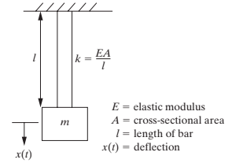

## Shaft

* + - 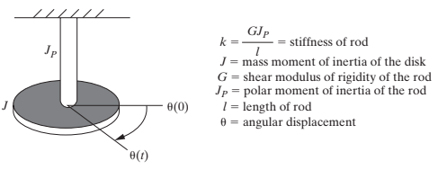

## Cantilever beam

$k=\frac{3EI}{L^{3}}$

$ω_{n}=\sqrt{\frac{3EI}{mL^{3}}}$

## Simply supported beam

* + - If $a=\frac{L}{2}$

$k=\frac{48EI}{L^{3}}$

## Spring

* + - * diameter of coil material
      * $n=$ number of turns
      * $2R$ = diameter of turn

# Springs

* + Series
 $\frac{1}{k_{eq}}=\frac{1}{k_{1}}+\frac{1}{k_{2}}+...$

 + Parallel

$k_{eq}=k_{1}+k_{2}+...$

# Modeling using energy method

* + - Spring (potential energy)
 $U=\frac{1}{2}kx^{2}$

 $\frac{dU}{dt}=kx\dot{x}$

  - Mass (kinetic energy)
 $T=\frac{1}{2}m{\dot{x}}^{2}$

 $\frac{dT}{dt}=m\dot{x}\ddot{x}$

  - Loss of energy (damper)

$\frac{dW}{dt}= -c\dot{x}dx$

# Stability

* + Oscillating system instability

## Flutter instability

* + Non-oscillating system direct instability

## Divergent instability

* + - If $c>γ$
      * We have our traditional stable system
    - If
      * + Flutter instability
 $ζ< -1$

       + Divergent instability

# Coulomb friction

* + - 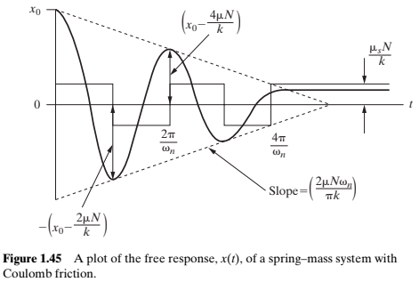

# Numerical simulations

* + Say $x_{1}=x$ and $x_{2}=\dot{x}$
  + Then $m\ddot{x}+c\dot{x}+kx=0$ becomes ${\dot{x}}_{2}=\frac{-c}{m}x_{2}-\frac{k}{m}x_{1}$
  + We can now have a linear system of equations:
 ${\dot{x}}_{1}=0x_{1}+x_{2}$

 ${\dot{x}}_{2}=\frac{=k}{m}x_{1}+\frac{-c}{m}x_{2}$

  - * We can solve this numerically

# Harmonic excitation without damping

* + - Note that $ω=ω_{n}$
 $f_{o}=\frac{F_{o}}{m}$

 + Method of undetermined coefficients leads to
 $x(t)=A_{1}cos(ω_{n}t)+A_{2}sin(ω_{n}t)+\frac{f_{o}}{{ω_{n}}^{2}-ω^{2}}cos(ωt)$

 $A_{1}=x_{o}-\frac{f_{o}}{{ω_{n}}^{2}-ω^{2}}$

$A_{2}=\frac{v_{o}}{ω_{n}}$

+ Resonance
    - If $ω=ω_{n}$
    - Rearrange equation and using some L’Hopital
 $lim_{ω→ω_{n}}x(t)=x_{o}cos(ω_{n}t)+\frac{v_{o}}{ω_{n}}sin(ω_{n}t)+\frac{f_{o}}{{ω_{n}}^{2}}\frac{ω_{n}t}{2}sin(ω_{n}t)$

 + Beating
    - If $ω_{n}≈ω$
    - Rearrange using $ω_{n}≈ω$ and trig rule
    - $ω_{n}-ω=ϵ$ and $ω_{n}+ω=2ω$
 $x(t)=(\frac{f_{o}}{2ϵω}sin(ϵt))sin(ωt)+x_{o}cos(ω_{n}t)+\frac{v_{o}}{ω_{n}}sin(ω_{n}t)$     * 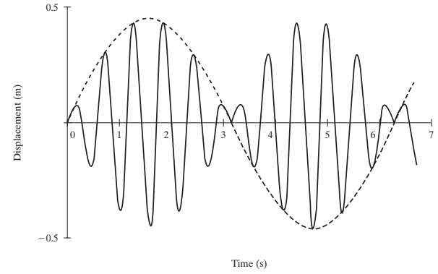

# Harmonic excitation with damping

* + - Rearrange into $\ddot{x}+2ζω_{n}\dot{x}+{ω_{n}}^{2}x=f_{o}cos(ωt)$
 $x(t)=exp(-ζω_{n}t)[A_{1}cos(ω_{d}t)+A_{2}sin(ω_{d}t)]+A_{s}cos(ωt)+B_{s}sin(ωt)$

 $A_{1}=x_{o}-\frac{({ω_{n}}^{2}-ω^{2})f_{o}}{({{ω_{n}}^{2}-ω^{2})}^{2}+(2ζω_{n}ω)^{2}}$

$A_{2}=\frac{ζω_{n}}{ω_{d}}(A_{1})-\frac{2ζω_{n}ω^{2}f_{o}}{ω_{d}[({ω_{n}}^{2}-ω^{2})^{2}+(2ζω_{n}ω)^{2}]}+\frac{v_{o}}{ω_{d}}$

$A_{s}=\frac{({ω_{n}}^{2}-ω^{2})f_{o}}{({ω_{n}}^{2}-ω^{2})^{2}+(2ζω_{n}ω)^{2}}$

$B_{s}=\frac{2ζω_{n}ωf_{o}}{({ω_{n}}^{2}-ω^{2})^{2}+(2ζω_{n}ω)^{2}}$

+ Transient response we multiplied by the $exp(-ζω_{n}t)$ and dies out over time

## Steady state response

* + - * The non-exponentially decaying terms $A_{s}cos(ωt)+B_{s}sin(ωt)$
  + The particular solution can also be written as
 $x_{p}(t)=Xcos(ωt-θ)$

 $X=\sqrt{{A_{s}}^{2}+{B_{s}}^{2}}=\frac{f_{o}}{\sqrt{({ω_{n}}^{2}-ω^{2})^{2}+(2ζω_{n}ω)^{2}}}$

 $θ=\tan^{-1}(\frac{B_{s}}{A_{s}})=tan^{-1}(\frac{2ζω_{n}ω}{{ω_{n}}^{2}-ω^{2}})$

 - We can study this equation to look at what happens at $ω_{n}=ω$
      * Resonance can’t happen though because the equation is fully defined for non-zero frequencies
        + Say $r=\frac{ω_{n}}{ω}$

$X=\frac{f_{o}}{{ω_{n}}^{2}}\frac{1}{\sqrt{(1-r^{2})^{2}+(2ζr)^{2}}}$

## Magnification factor

* + - * + Recall the deformation $δ=\frac{F}{k}=\frac{f_{o}}{{ω_{n}}^{2}}$
 $M=\frac{X}{δ}=\frac{1}{\sqrt{(1-r^{2})^{2}+(2ζr)^{2}}}$

       + Graph $M(δ,r)$

